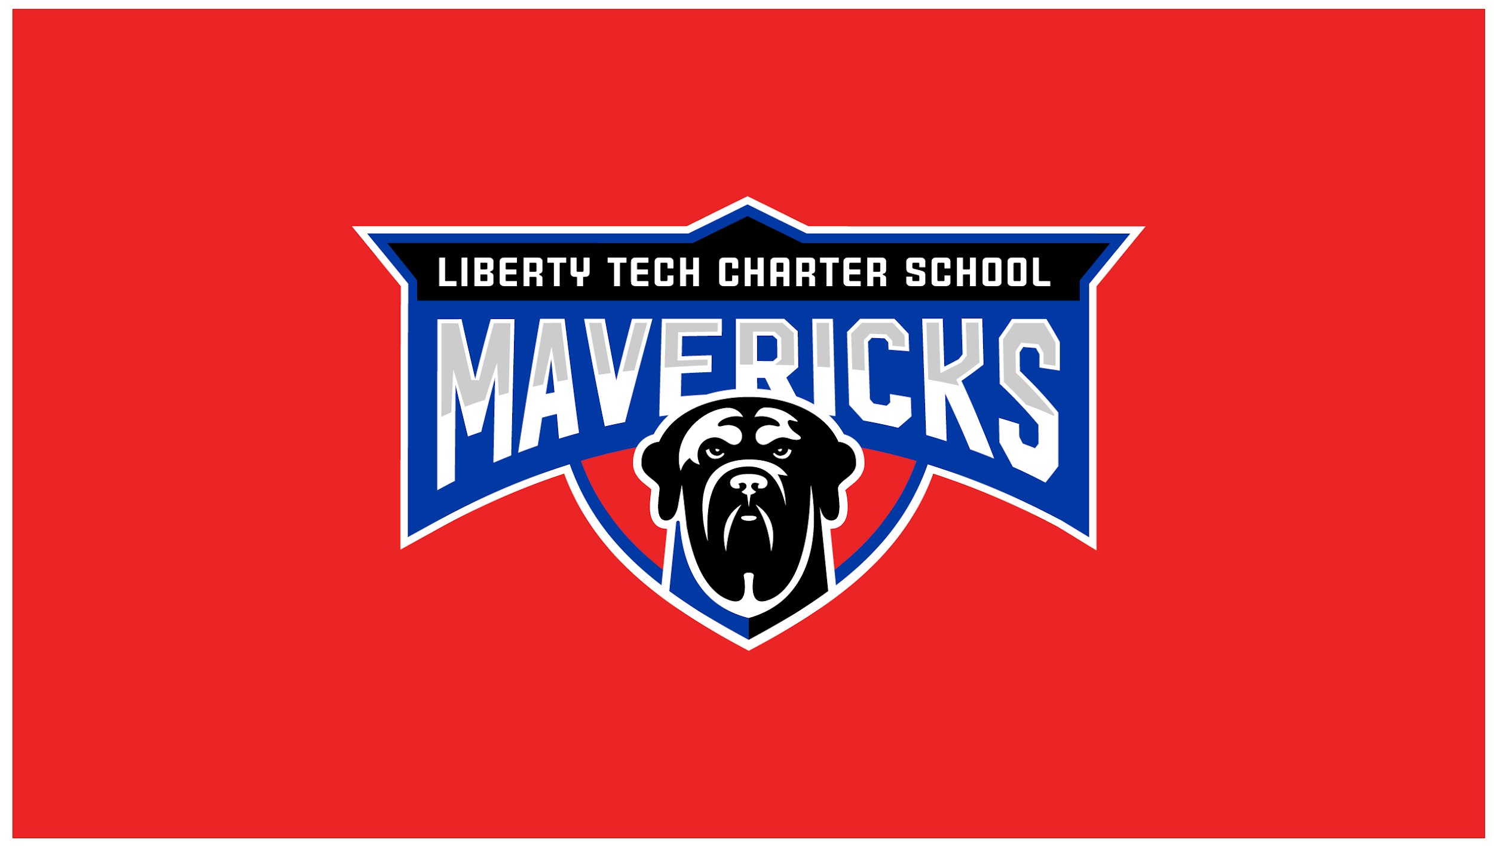
Liberty Tech Charter School
119 Price Rd., Brooks, GA 30205
Monthly Board Meeting
May 20th, 2024 | 7:00 PM
__________________________________________________________________________________
- VISION - We believe the education process should be innovative, exciting, and a place where the status quo is not tolerated. We do this by creating a holistic community that prepares our students for success by giving them the freedom for self-directed learning, instilling critical thinking skills, developing an engaging and challenging learning environment, and enriching the whole child by focusing on our core virtues: Temperance, Justice, Prudence, and Fortitude.
__________________________________________________________________________________
This meeting will be held in-person virtually via Google Meets. Participants may join the meeting via Google Meets or by phone:
- Meeting URL: https://meet.google.com/bqq-agqb-dvn
- Dial-In Number: +1 513-760-6678
- Dial-In Meeting PIN: 325 673 941‬#
*Public comments may be emailed to board@libertytechcharter.org by 8:00 AM on the meeting date or submitted via the teleconference chat window during the allotted public comment sign-up time, 30 minutes prior to the meeting. Please reference our public comment policy on our website at
www.libertytechcharter.org/ltcs-board.
__________________________________________________________________________________
Board Members
Todd Levin, Board Chair | Vimal Patel, Vice-Chair | Robert Varghese, CFO/Treasurer | Ashley Busby, Member | Jeremy Tuck, Member | Nathan Flint, Member | Eric Ochsner, Secretary
Next Meeting: June 27, 2024

Time | Item | Purpose | Owner
7:00pm | Record Attendance | Approve | Todd Levin
7:01pm | Call the Meeting to Order | Approve | Todd Levin
7:02pm | Approve March Meeting Minutes | Vote | Todd Levin
7:03pm | Approve April Meeting Agenda | Vote | Todd Levin
7:04pm | *Public Comment (General Public Comment) | Discuss | Public Guests
7:20pm | PTO Update | Discuss | PTO Member
7:25pm | Superintendent Report  - April Dashboard | Discuss | Melissa King
7:45pm | Finance Committee Report  - Review Financials  - Review the 2024 / 2025 Budget | Discuss | Robert Varghese
7:55pm | *Public Comment Relating the Proposed Budget | Comments | Public Guests
8:00pm | Academic Committee Report  - Recap of last Academic Comm Mtg | Discuss / Vote | Nathan Flint
8:10pm | Governance Committee Report  - SCSC Training Schedule / Completion  - Update on new Policy Manual  - Review of Charter modifications  - Addition of Dr. Mislap | Discuss / Vote | Vimal Patel
8:20pm | Development Committee Report  - Recap of last Dev Comm Mtg | Discuss | Jeremy Tuck
 | Executive Session – Not Required | Discuss | N/A
8:25pm | Action Item Review | Discuss | Eric Ochsner
8:30pm | Adjournment | Vote | Todd Levin

